INNOVATION IN INTERNATIONAL BUSINESS TEACHING PEDAGOGY: FINDING CULTURAL SIMILARITY AND DIFFERENCES THROUGH STUDENT GROUP RESEARCH

MOUSUMI BHATTACHARYA
Charles F. Dolan School of Business
Fairfield University
Fairfield, CT 06824
Tel: (203) 254-4000 ext.2893
Fax: (203) 254-4105
E-mail: mbhattac@fairfield.edu

ABSTRACT
Understanding global culture is crucial to conducting successful international business, especially in the human resource management (HRM) area. For application of HRM policies across countries it is essential that factors that influence culture are understood. However, not many international HRM textbooks focus on factors that influence culture, as most of them strive to teach the content areas of HRM. Textbooks on culture, on the other hand, rely on status quo of cultural dimensions. The purpose of this paper is to examine, how undergraduate students understand factors that affect culture in different countries and regions. Two different types of student group research projects were used for this purpose – one with a broad scope and one with a focused scope. The students, through group-directed research, discovered cultural factors that may affect HRM in a country or region. Content analysis of the research papers, reveal, how different aspects on international HRM come alive through students’ narration of cultural factors. Further analysis shows how framing of the project from a broad international HRM perspective to a focused cultural perspective, enhance achievement of learning objectives. We convey how the results from this pedagogical innovation can be used and what are the future research areas.

INTRODUCTION
In a globalized world, multicultural interaction is increasingly occurring (Slaughter, 2013). Culture is defined as “The ideas, customs, and social behavior of a particular people or society” (“Oxford Dictionaries | English,” 2018). Culture plays a large role within the workplace, and can become especially prevalent when managing people from different countries and regions of the world. Businesses from various parts of the world incorporate their national cultures into the workplace (Hauff, and Kirchner, 2015). When companies extend their business across countries and regions, it is likely that their own cultures will play a part in their management style (Bosco and Lawrence, 2018). International human resource management (HRM) addresses these issues in managing people from different countries and regions.
In teaching International business, oftentimes, the differences amongst cultures is what is analyzed (Craig, Douglas, and Grein, 1992). However, it may be better to focus on the commonalities; cultural similarities help interactions among people from different cultures. In many studies, cultural similarities have “been found to foster mutual trust, reduce transaction costs, and facilitate economic exchange” (Shi, W., & Tang, Y., 2015). Understanding cross-cultural similarities can strengthen relations when conducting international business. Recognizing similarities in various aspects of culture can lead to act on the common ground between multinational companies. This bond forges stronger relationships which can carry into the future and strengthen relationships among people from culturally diverse backgrounds. Additionally, implementation of HRM policies and practices across different nations and regions, is facilitated by this knowledge of similarities and differences among cultures (Berber, Slavić, Morley, and Poór, 2017).
Many factors affect culture and a focus on these factors help understanding of similarities and differences in culture. For example the factor ‘time’ explains differences and similarities in work culture in different regions of the world (Lewis, 2014). However, business school education, in general, do not focus much on ‘culture’ (Storti, 2013). Having taught an international HRM class for over fifteen years, I found that international HRM texts do not adequately highlight cultural factors that may lead to differences and similarities. The few texts that do are more ethnography-based and it is difficult to integrate them, along with an international HRM text, in one course. Feeling this need I developed an assignment to focus on international HRM and the effect of cultural factors on different HRM policies and practices (Berber, Slavić, Morley, and Poór, 2017). This assignment, a semester-long project in the capstone course, is required for all management majors. Entirely based on student research done in groups, the project is geared towards the learning outcome of the capstone course – integrating the knowledge of managing people for global business. This assignment brings together cultural factors that influence international HRM, from the point of view of the students.
In this paper I analyze the group research reports to investigate how undergraduate students learn about cultural similarities and dissimilarities and factors that affect them. I first review the literature on a) the factors that contribute towards similarities and dissimilarities across cultures; b) what role these similarities and dissimilarities play in the international business community. This paper contributes to the pedagogy of teaching international business in several ways. First, it showcases an innovative group-research based assignment that integrates international HRM and cultural factors analysis. Second it focuses on how to enhance students’ perception of factors that affect culture, an area where cultural sensitivity needs to be developed. Third, understanding the factors through group-driven research provides a framework to create long term knowledge in the minds of the students. Additionally, the findings from this paper advances the knowledge about cultural similarities and dissimilarities among countries and world regions. Previously researchers have mostly focused on similarities and dissimilarity separately. In this paper we put them together. Finally, practitioners will find this framework useful too. Some of the factors discussed within this paper may be the similarities companies find with their foreign counterparts; they can then focus on these similarities during transactions. This will likely create a sense of familiarity between the two companies and ease tensions. Factors which prove to be different between companies should be handled more carefully during business interactions so as to not create any tension.
THEORY DEVELOPMENT
Business pedagogy is criticized for relying on existing theory rather than creative understanding of global complexity (Cheng, 2007). AACSB (2011) claimed that business schools have largely failed to contextualize global complexity and uncertainty in education. As Tchaïcha and Davis (2005) point out,
“Business schools not only need to focus on educating students in the traditional business disciplines, but they also need to broaden their curriculum focus. Specifically, they need to place more emphasis on (a) how culture can influence and shape operations strategies (i.e., in terms of how businesses compete) in a foreign country, and (b) how students can recognize and appreciate the differences that exist between their own culture(s) and those of others.”
The sense of status-quo also shows up in international HRM textbooks where the focus is on how multinationals design and implement HRM policies and practices across countries. The theories in the texts do not engage in detailed discussion on the factors that affect cultural similarities and differences, which may, in turn, influence international HRM. Culture textbooks, on the other hand, focus exclusively on culture and hardly brings in its effect on various HRM policies or practices. So, although there is a need for international HRM and culture to be taught together, it is difficult to accommodate two different textbook contents in the same course, especially at the undergraduate level.
Cultural Factors
Culture is a multi-level construct, comprising of a stable set of shared values, beliefs, traditions, norms and artifacts (Taras and Kirkman, 2016). Many disciplines, such as psychology, anthropology, sociology, study culture. In psychology, researchers study both universal (etic) and culture-specific (emic) psychological principles (Segall, Lonner, and Berry,1998). For cross-cultural psychologists, culture is learned and bounded by a group’s behavioral norms, values, beliefs and symbols (Hofstede, 1991). The culture-bound constructs can be used to understand and explain similarities and differences in psychological processes across cultures (Triandis, 1996). In the business world this is called similarities and differences among cultures that affect international business, especially HRM policies and practices. Next, I explore the factors that affect business culture, discussed within business journals.
Religion
Defined as “a cause, principle, or system of beliefs held to with ardor and faith”, religion plays a dominant role in several regions of the world (“Merriam-Webster,” 2018). Not only does it represent a larger, national culture, but it oftentimes plays “a crucial role… in defining individual and group identities,” (Shi, W., & Tang, Y., 2015). It is no coincidence that a force such as religion, which has etched itself into the lives of billions, has the potential to intervene in workplace culture. For example, Islam requires that followers pray five times a day; therefore, during the workday, “some individuals will take turns and pray, while others will shut down their business during the time of prayer” (Abdulateef Al-Mulhim, 2013). Other cultures may be more agnostic or atheist and have no religious connections to their businesses. In either situations, religion, or the lack of, has proved to be influential within the workplace and business relations. Determining the role religion possesses in a society is crucial to better understanding how to conduct business with that region. In addition, previous studies have revealed that “firms… that are similar in religious beliefs and ethnic backgrounds are more likely to establish alliances” (Shi, W., & Tang, Y., 2015). Instead of honing in on religious differences, which has often been the case, finding religious similarities can be key improving and sustaining international business relations.
Values
Oftentimes, values define a nation as well as its people. This is why it is critical to take into consideration this factor when conducting international business. In a study conducted by the Journal of Technology Management in China, it was found that there were several similarities between the USA, Canada, & the UK. This was mainly on the account that “[they] have similar forms of common law governmental systems” (Feikis, J., McHugh, A., & Lane, S.,2014). In addition, this study demonstrated that values are deeply ingrained into a nation’s culture, althemore reason for delving into what similar values businesses share.
Education
Education is the crux to an improved life. However, its quality and quantity fluctuates across the world. This variance is seen between businesses & the education level between employees. In order to spread education, for it is a positive factor, one has to “take into account… the persistent cultural differences” between nations (Kivinen, 2003). Educational differences take a toll on business relations and it is important to keep those in mind in order to conduct commerce successfully. Education is one of the key factors to appear when assessing cultural comparisons and it is necessary to evaluate those differences/similarities to ensure successful international business.
Communication
Communication is defined as an “exchange of information”, and indeed this exchange is pivotal to forging and maintaining relationships, whether they be local, national, or global (“Merriam-Webster,” 2018). Especially in the world of international business, communicating is integral to forging partnerships between multinational companies. It can present itself in many forms- verbal, non-verbal (body language), or through written form-, all of which require exploration to determine the best form to utilize when interacting with specific regions. Oftentimes, culture and communication style go hand in hand, and it is necessary to understand this relationship before conducting business with foreign companies.
Sense of Time
Finally, time perception can play an important role in international business. For some, such as the Americans, “time is truly money [and]... it flows fast” (Lewis, 2014). In these such cultures, time is monochronic, or linear and everything, including business, is conducted at a fast, rigid pace. Other cultures, such as those in South Europe, are more multi-active, meaning, “the more things they can do at the same time, the happier they feel” (Lewis). Additionally, other cultures, primarily those in Asia, think more in the long-term and cannot complete tasks hastily; this perception of time is known as cyclic. Indeed, notions of time can vary significantly, and understanding the fluctuations across cultures can be critical when conducting international business.
Course Description
The International HRM course is part of the International Business major program. It is also the capstone course for Management major students. Students in this course are all upperclassmen juniors and seniors. The learning goals of the course are to understand the complexities of managing people across global cultures; and specifically to focus on how cultural similarities and differences affect human resource management in different regions and countries of the world.
The students work in groups on a semester long project. There are 5-6 groups each semester, with 4-5 members in in group, for a total of 20 - 30 students each semester. Two somewhat distinct version of the project was used in the last four years. Initially the project was designed as a comparative global human resource management project (see Table 1A). However, I felt that the broad scope of the project was confusing to the students. Subsequently the project was modified as culture analysis and human resource management implications in different regions of the world (see Table 1B). Accordingly I hypothesize that,
Hypothesis 1: Students’ perception of cultural similarities and dissimilarities will be higher in the ‘Post’ form of the project.
Hypothesis 2: Students’ perception of application of cultural similarities and dissimilarities on international business will be stronger in the ‘Post’ form of the project.
Methodology
I took thirteen student group project papers from four semesters over two nonconsecutive years. In total 45 students were covered in these papers. Of the papers read, half were placed in the ‘pre’ category while the other half were labeled as ‘post’. The specifics as well as descriptions of the respective assignments can be found in Table 1A and 1B. During the first two semesters the ‘Pre’ form of project was administered (see Table 1A); during the second two semesters the ‘Post’ form of the project was given (see Table 1B). The ‘Pre’ groups’ task was to establish a business in a country of their choice. The students had to explain why they had chosen this location over the other possibilities; in addition, they had to provide details about the set-up of their companies. On the other hand, the ‘Post’ projects were assigned to choose a region in the world. They would then compare the culture of that region to the United States; ultimately, they described what the implications for human resource management within that region would be.
Not only would I be looking at what aspects of cultural similarities appeared throughout the papers, but also how the appearance and relevance of these aspects varied between the two samples. To further specify the research, the cultural similarities were divided into five factors: religion, values, communication, education, and sense of time. These were determined from the literature review as well as through their frequency within the papers. Moreover, the factors were divided into subsets, providing additional depth to the project. These subsets can be found in Table 3.
In this project, I utilized the process of content analysis, defined as “systematic coding and categorizing approach used for exploring large amounts of textual information unobtrusively to determine trends and patterns of words used, their frequency, their relationships, and the structures and discourses of communication” (Vaismoradi, Turunen, and Bondas, 2013). Within content analysis, there is a three step process of preparation, organization, and recording. These steps, in relation to this project, are explained in greater detail.
As I read through the papers, I created an Excel spreadsheet to tally the occurrence of the factors as well as their subsets. When a factor appeared relevant to the region of the paper, I would mark it down onto the spreadsheet. Two sheets were created, one for the ‘Pre’ papers and one for the ‘Post’ papers. Ultimately, the data obtained from reviewing the students’ papers was formatted into a frequency table in the form of a double bar chart, as displayed in Table 3. This form of data presentation allows for a side by side comparison between the two sample sets as well as an analysis of the role of the factors recorded.
I completed a similar process when I went through both sets of papers to determine the frequency of culture in relation to workplace applications. Four categories were created: recruitment, training, compensation, and employee relations. Then, the amount of times culture appeared in separate occasions regarding these topics was tallied and noted down in an Excel spreadsheet. In addition, I took down statements from all of the paper’s for each category, regardless of whether they included culture in them or not.
Data Analysis
Overall, the two sample sets contained 13 papers, 7 of which were ‘Pre’ and the remaining 6 were ‘Post’. Each paper was about 15-18 pages in length and they were divided into sections according to their project requirements (found in Tables 1A & 1B). As I read, I looked for factors within the region’s culture which could potentially affect the workplace. Searching for factors, combined with the initial literature review I had completed allowed me to pinpoint the five factors which would serve as the cornerstones in assessing the similarities/dissimilarities between cultures. Once the five factors were decided upon, the rest of the papers were read with the sole purpose of locating, if they existed within the paper, any of those factors, along with their subsets. The number for each factor depended on how many times the mention of them occurred in different sections of the papers. Each time I read a paper, tally marks were added to the Excel spreadsheet to keep count of the factors’ frequencies. Finally, all the data was displayed in a frequency chart, as seen in Table 3.
Some of the data was easier to extract as it was stated in a straightforward manners within the papers; a few direct quotes from each of the papers are recorded in the Sample Statements in Table 2A & 2B. Other data was more indirect but implied an importance of one or more factors and their subsets within a region’s culture; these tally marks stemmed from my own interpretation/reading of the students’ papers.

DISCUSSION

Many differences presented themselves between the ‘Pre’ and ‘Post’ papers. First, the distinction between the frequency of the factors, as depicted in Table 3, were very apparent. Altogether there were five factors- religion, values, education, sense of time, and communication. Each of the factors had been broken down into subsets: values split into morals, tradition, trust, and workplace relationships, education split into quality and quantity, communication split into verbal, non-verbal (body language) and written, and sense of time split into rigid and relaxed. Three factors- religion, education, and communication- appeared more often within the ‘Pre’ papers; the highest occurring of these three was education. The other two factors, values and sense of time, were much more frequent throughout the ‘Post’ papers. However, the difference between the factors which ‘Pre’ papers dominated in were marginal compared to the enormous differences among the frequency of the two factors ‘Post’ papers lead in. The factors which had a greater frequency within the ‘Pre’ papers were factors which could pertain to the type of project they were conducting. For this reason, the ‘Pre’ papers rarely mentioned ‘values’ and there was a complete lack of how sense of time factored into the workplace; these factors play little to no role when considering a global location to establish a business. Rather, they are factors which would be a point of focus when discussing the culture of a location & how that culture affects the workplace, and this was apparent in the ‘Post’ papers.
Overall, the ‘post’ papers provided a more comprehensive explanation of how various factors affected the region, and in turn, the workplace. The quotes in Sample Statement Table in Table 2A & 2B depict this contrast. For example, the ‘Post’ papers, as seen in Table 2B, were more explicit with how religion affected the workplace; in many instances, they specified what the predominant religion was in the region and whether workers were in fact religious enough to put faith as the first priority. However, the ‘Pre’ papers simply referred to religion in terms of whether they would institute a non-denominational prayer room. They did not delve any further into specifics. Likewise, when communication appeared in ‘pre’ papers, it predominantly referred to the fact that employees would have to be bilingual: whereas in the ‘Post’ papers, the communication styles were discussed more in-depth, covering both written and nonverbal (body language) communication and what forms of interaction various regions preferred. To potential international business partners of the region, the latter information would promote more effective interaction, especially if some of the communication styles were common between the two companies’ cultures. Though the ‘Pre’ papers may have had a higher frequency of mentioning factors between the two sample sets, the ‘Post’ papers were overall more direct with how these factors affected the workplace and took a part in the culture. It was clear that the ‘Post’ papers relayed more comprehensive information regarding cultural similarities and how these similarities/dissimilarities affected the workplace.
On the other hand, with regards to the second frequency table (5A & 5B), it appears as though both the ‘Pre’ & ‘Post’ papers incorporated culture into their analysis of HRM factors. This is in keeping with their respective project assignments; the ‘Pre’ papers had the task of delving into how HRM varied in countries, automatically including cultural aspects as part of their findings, and the ‘Post’ papers focused on culture as it impacted businesses as a whole, including HRM factors. One difference would be that, when looking at Table 4A, ‘Post’ papers, overall mentioned culture in relation to HRM factors, with the exception of training, more frequently than ‘Pre’ papers. Once again, this variance can be attributed to the fact that the ‘Post’ papers were designed to analyze culture specifically unlike the ‘Pre’ papers.
Other observations appeared as I read the papers. The regions with a more rigid sense of time were the ones with a more individualistic society, one of the standards of Hofstede's Dimensions. This difference could be extended to the communication style preferred as well; regions with a more relaxed sense of time were those who preferred communication face to face. On the other hand, areas where time was more rigid and strict, communication was preferred to be written, by email and such. Punctuality was key in these societies because in turn it could also feed into the individualistic portion of the Dimensions, where every worker’s ultimate goal is to see his/herself succeed and climb up the socioeconomic ladder. To be considered for promotions, the worker would have to convey competence and one form of that would be punctuality and meeting deadlines. Overall, when the students focused more on national cultures and their relevance to the regions’ workplace it was easier to find connections between the factors. It was also clear that they had a better sense of what the cultural similarities were between regions as well as dissimilarities
CONCLUSION

Our global community is composed of a myriad of different cultures. Understanding the various aspects of these cultures, and learning how they compare with one’s own is integral to forging relationships and sustaining relations. This is especially relevant to international business as oftentimes, exposure to different cultures is key to sustaining business relations. In the past, cultural differences have been the defining trait in cross-cultural comparison. However, this project delves not only into cross-cultural dissimilarities, but cross-cultural similarities as well. The cultural aspects found were divided into factors and the frequency of these factors within the student papers was displayed in Table 3A & 3B. Through this project, my findings revealed certain factors which play the largest role within cross-cultural understandings of students. In addition, as two sample sets of student papers were taken, it was clear when reviewing results that the second group of students, or the ‘Post’ papers, had developed a greater understanding of applying cultural comparisons to international business. In order to further that understanding, for both teachers and students, future assignments should be molded along the lines of the project the ‘Post’ papers were assigned.
The findings within this project can most certainly be expanded. The factors discussed in this paper can be further researched to discern how exactly they play a role in the workplace. Additionally, as this project related information on a more general scale, future research could focus on how the factors are similar/dissimilar across specific countries and/or regions. Lastly, this paper only revolves around five factors of culture; there are many more which were not discussed, and which could be the potential topic of research for future initiatives. In addition to future research, international business could potentially benefit from the findings in this paper. The factors discussed within this project can be focused on when dealing with international business. Similarities across regions can be explored in greater detail and utilizing these similarities to their full potential would increase the application of HRM in international business.

REFERENCES

(2018). “Merriam Webster”. Retrieved from
https://www.merriam-webster.com/dictionary/communication
(2018). “Merriam Webster”. Retrieved from https://www.merriam-webster.com/dictionary/religion
(2018). “Oxford Dictionaries | English”. Retrieved from en.oxforddictionaries.com/definition/culture.
Abdulateef Al-Mulhim (2013). Arab News: Sorry! Closed for Prayer. Retrieved from http://www.arabnews.com/news/486146
Berber, N., Slavić, A., Morley, M. J., & Poór, J. (2017). Management compensation systems in Central and Eastern Europe: a comparative analysis. International Journal of Human Resource Management, 28(12), 1661–1689.
Bosco, S., & Lawrence, E. (2018). Effects of National Culture on Management Style. Proceedings for the Northeast Region Decision Sciences Institute (NEDSI), 80–81.
Cheng, J. (2007), Critical issues in international management research: an agenda for future advancement, European Journal of International Management, Vol. 1 Nos 1/2, pp. 23-28.
Craig, C. S., Douglas, S. P., & Grein, A. (1992). Patterns of convergence and divergence among industrialized nations: 1960-1988. Journal of International Business Studies, 23(4), 773–787.
Feikis, J., McHugh, A., & Lane, S. (2014). Ethics and values. Journal of Technology Management in China, 9(2), 108-122.
Hauff, S., & Kirchner, S. (2015). Identifying work value patterns: cross-national comparison and historical dynamics. International Journal of Manpower, 36(2), 151–168.
Hofstede, G. (1991). Empirical models of cultural differences. In N. Bleichrodt & P. J. D. (Eds.),
Contemporary Issues in Cross-cultural Psychology (pp. 4–20). Amsterdam, Netherlands: Swets
& Zeitlinger.
Kivinen, O., & Nurmi, J. (2003). Unifying higher education for different kinds of Europeans. higher education and work: A comparison of ten countries. Comparative Education, 39(1), 83-103.
Lameli, A., Nitsch, V., Sudekum, J., & Wolf, N. (2015). Same same but different: Dialects and trade. German Economic Review, 16(3), 290-306.
Leung, W. O., Liang, X., Priem, R., & Shaffer, M. (2013). Top management team trust, behavioral integration and the performance of international joint ventures. Journal of Asia Business Studies, 7(2), 99-122.
Lewis, Richard. (2014). How different cultures understand time. Business Insider. Retrieved from https://www.businessinsider.com/how-different-cultures-understand-time-2014-5
Segall, M. H., Lonner, W. J., & Berry, J. W. (1998). Cross-cultural psychology as a scholarly
discipline: On the flowering of culture in behavioral research. American Psychologist, 53,
1101–1110.
Shi, W., & Tang, Y. (2015). Cultural similarity as in-group favoritism: The impact of religious and ethnic similarities on alliance formation and announcement returns. Journal of Corporate Finance, 34, 32.
Slaughter, M.J. (2013), American Companies and Global Supply Networks: Driving US Economic Growth and Jobs by Connecting with the World, The Business Roundable, Washington, DC, available at: www.uscib.org/docs/2013_american_companies_and_global_supply_networks.pdf
Storti, C. (2013). Playing catch-up. Journal of International Education in Business, 6(2), 200-206.
Tchaïcha, J.,D., & Davis, M. M. (2005). The impact of culture on technology and business: an interdisciplinary, experiential course paradigm. Journal of Management Education, 29(5), 738-757.
Taras, V., Steel, P., & Kirkman, B. L. (2016). Does country equate with culture? beyond geography in the search for cultural boundaries. Management International Review, 56(4), 455-487.
Triandis, H. C. (1996). The psychological measurement of cultural syndromes. American
Psychologist, 51, 407–415.
Vaismoradi, M., & Turunen H. (2013). Content Analysis and Thematic Analysis: Implications for Conducting a Qualitative Descriptive Study. Nursing & Health Sciences, vol. 15, no. 3, 2013, pp. 398–405.
Westwood, R. I., & Posner, B. Z. (1997). Managerial values across cultures: Australia, Hong Kong and the united states. Asia Pacific Journal of Management, 14(1), 31-66.
Woldu, H. G., Budhwar, P. S., & Parkes, C. (2006). A cross-national comparison of cultural value orientations of Indian, Polish, Russian and American employees. The International Journal of Human Resource Management, 17(6), 1076.
Woldu, H. G., Skuza, A., Dalgic, T., & Altinbasak, I. (2012). Viewing the cultural value orientations of Austria, Poland, and Turkey through six cultural dimensions: An emphasis on Turkish cultural fit to European union members. The Poznan University of Economics Review, 12(4), 51-71.
TABLE 1A: COURSE DESCRIPTION AND PROJECT DESCRIPTION - PRE

Course Overview and Objectives
This course explores the complexities of managing people in the global business arena. Globalization, through international alliances, mergers, joint ventures, entry into new markets such as China and India, and offshoring, is the way of business today. We have seen a dramatic increase in work teams across several countries (virtual or otherwise), globally outsourced work, and cultural diversity in the workplace. A major challenge posed by this new business landscape is the need to understand the similarities and dissimilarities in human resource management (HRM) practices across different cultures and countries. HRM entails recruiting the best, motivating them to perform their best, and providing them with a rewarding and fulfilling career. All these take on new meaning when applied in the global business arena where people from different cultures and countries work together. HRM practices like recruitment, training, compensation and benefits, performance management, and employee relations become more complex. Legal and regulatory requirements of foreign countries, cultural differences, expatriate management, workforce mobility etc. become important considerations. In this course we shall analyze some of these concepts and issues.

The primary learning objectives of this course are to:
· Get familiar with the complexities of Global Human Resource Management
· Develop research and real world application skills specific to this subject

PROJECT: Comparative Global Human Resource Management (HRM) Analysis
This group project consists of a presentation and a written report. Each group is assigned a region of the world and a presentation date as follows:

Group | Region | Examples of Countries
1 | Latin America | Brazil, Chile, Argentina, Mexico, Puerto Rico
2 | Asia Pacific | Singapore, Indonesia, Malaysia, Philippines, Korea
3 | Eastern Europe/ Western Asia | Poland, Bulgaria, Czech Republic, Russia,. Ukraine, other Baltic countries
4 | Middle East | Turkey, Egypt, Israel, Saudi Arabia, Kuwait
5 | Africa | Kenya, Nigeria, Tanzania, South Africa

Within your region select one country for each group member. For each country, select a target city. Now select one of the following two scenarios in any industry or for any company (real or fictitious):
Scenario A: Your Company is interested in opening regional headquarters in this geographic region. This regional HQ will need to contain the regional management/administrative functions, regional sales and marketing, and other staff functions. There will likely be some expatriates from HQ, third country nationals, and local nationals working from the same location. Your group should fill in some details about your hypothetical organization to make the presentation more interesting and more relevant. You may specify the service.
Scenario B: Your Company is looking for a location for a new production facility in your geographic region. This production facility will hire many local workers for all aspects of the facility (e.g., production, supervision, quality, shipping, and other line functions). There may be a few (but not too many) traditional expatriates. Your group should fill in some details about your hypothetical organization to make the presentation more interesting and more relevant. You may specify the product(s).
You will research, compare and contrast the countries/cities you have selected from the given geographic region, based on business strategy and HRM factors. That is, you will be doing a comparative global strategic HRM analysis for each city/country combination and will put forth a proposal for a "recommended city" within the region.The recommendation should also contain a detailed HRM plan for implementation i.e. the HR practices that you propose in that country/city. You will also make a 30 minute presentation (12-15 PowerPoint slides) to the executive committee of your company regarding the pros and cons of each location from the global human resource management perspective. The focus of the presentation is how the management of your human talent will affect the ability to be successful in that region.
You will need to discuss the following strategic and global HRM factors for each of your target city/country combination. There should be two appendices, one for Business Strategy Factors and one for HRM Factors, showing the comparisons with ranking/rating for each country/city combination on each factor items.

Business Strategy Factors(all required)
1. Economic profile (economic development, GDP, currency/exchange rate, purchasing power)
2. Political (type of government, control over foreign companies etc.) and social issues (demographics, level of education, corruption index, women in business etc.)
3. Industry profile for your chosen industry (total sales worldwide, expected sales in that region, major corporations in that region)
4. Logistics of operation (availability of electricity, water, transportation, port etc.)

HRM factors(1-7 required, rest depends on country/city)
1. Need for talent (for various job categories, managerial and others) based on business strategy
2. Availability of talent (expatriates, local, third country nationals) and turnover rates
3. Competence of workforce (education/experience), training needs, availability of training facilities
4. Salary and wages, incentives and bonuses
5. Medical and health systems, availability of housing, schools, etc. for expatriates, other benefits
6. Labor and management relations, legal obligations and concerns affecting HR and Labor Relations
7. Cultural dimensions (e.g. individualism/collectivism)) - how do they affect the HRM practices
8. Ethical concerns regarding hiring, child labor, bribery, nepotism etc.
9. Religion and level of orthodoxy as it affects HRM
10. Level of formality (i.e., deference, hierarchy), value of time and time consciousness

TABLE 1B: COURSE DESCRIPTION AND PROJECT DESCRIPTION - POST

Course Overview
This course explores the complexities of managing people in the global business arena. Globalization, through international alliances, mergers, joint ventures, and offshoring, is part of strategic management of the firm. A major challenge posed by global business is the need to understand the similarities and dissimilarities in people and business practices across different cultures and countries. A broader and deeper understanding of cultural similarities and differences is called for in order to manage people well in this globalized world.

Strategic human resource management (SHRM) entails recruiting the best, motivating them to perform their best, and providing them with a rewarding and fulfilling career. All these take on new meaning when applied in the global business arena where people from different cultures and countries work together. As the firm operates in global markets, hires foreign employees, or outsource work to foreign countries, SHRM practices like recruitment, training, compensation and benefits, performance management, and employee relations become more complex. Legal and regulatory requirements of countries, cultural differences, expatriate management, workforce mobility etc. become important considerations. In this course we shall analyze these complexities and discuss SHRM issues for global companies.

The primary learning objectives of this course are to:
· Get familiar with the complexities of managing people for doing business globally.
· Analyze culture-specific strategic human resource management issues.

PROJECT: Culture Analysis and Human Resource Management Implications in Different Regions of the World

Your group is given a world region.
Group 1: Latin America
Group 2: Central and Eastern Europe
Group 3: Asia Pacific (excluding China)
Group 4: Africa
Group 5: Middle East
Group 6: China
You would analyze the region based on research on
- Culture of the region
  - History and Politics
  - Religion and philosophy
  - Arts and media
  - Education
  - Social systems and economy
- How the culture is similar to or different from that of the USA?
  - Hofstede’s dimensions - individualism vs collectivism, power distance, masculinity vs femininity, uncertainty avoidance, long term vs short term orientation
  - Other aspects - notion of time, speed, teamwork, communication process (verbal, written)
- What are the implications for human resource management when setting up a wholly owned subsidiary in that region? Focus on the strategic aspect i.e. implications for firm performance, group performance and individual performance
  - Recruitment
  - Training
  - Compensation
  - Performance Management
  - Employee Relations
The Culture Analysis consists of a presentation and a report. The presentation is 15-20 minutes as per class schedule. The report is 10-12 pages (excluding cover page, executive summary, table of contents, bibliography, appendices), single spaced, 12 font. Concepts from the textbook (Ibraiz, Briscoe and Schuler, 2015) should be linked to your analysis. Textbook need to be cited in-text at least five times in the analysis. All sources of information should be cited in-text and referenced in the bibliography in APA style.

TABLE 2A: SAMPLE STATEMENTS ON DIFFERENT FACTORS - PRE

FACTOR | Statement #1 | Statement #2
Religion | “The Mexican culture is dominated by the Catholic Church and therefore Free Spirit Swimwear will have onsite a non-denominational place of worship.”- Latin America  CTE: Identify | “In the Philippines, there is a prominent Christian presence and also a Muslim population. We accept and are able to accommodate for all religious backgrounds…”- YoCrazy Frozen Yogurt  CTE: Identify
Values | “Maintaining strong employee relations within the company will be critical for our success.”- Indonesia/South Korea
Communication | “... we recommend that every employee in our company is able to speak at least two languages: the host country’s language… and English.”- Hotel Industry in the Middle East | “We will require supervisors to be bilingual…”- Latin America
Education | “Suwon is a major educational center, being home to 11 university campuses.”- Indonesia/South Korea | “The people of the Czech Republic have a 99% literacy rate, and a school life expectancy of 15 years, therefore the potential workforce can be assumed to be well-educated.”- Eastern Europe

TABLE 2B: SAMPLE STATEMENTS ON DIFFERENT FACTORS - POST

FACTOR | Statement #1 | Statement #2 | Statement #3
Religion | “The effect religion has on the culture of the Middle East is tremendous… Muslims must take time out of their day whether they are at home or working to say their prayers.”- Middle East  CTE: Explain | “Religion actually has a huge impact on the workforce and the way the Philippines operates from a business perspective.”- Asia Pacific  CTE: Explain | “Religion… in Latin America influence the professional environment very heavily.”- Latin America  CTE: Explain
Values | “One of the key takeaways from this project was the importance of relationship building and the establishment of trust to allow for streamlined business operations.”- China | “... the main likeness among African countries consists of the devotion to society and the customs and morals that are upheld.”- Africa | “These countries have a strong relationship with those around them… The relationships between those in charge and the subordinates are seen as ‘familiar’.”- Asia Pacific
Communication | “Personal communication is important in Latin America because employees prefer interaction face-to-face...”- Latin America | “Gestures are taken seriously, and eye contact is the most important factor in earning trust.”- Central and Eastern Europe | “In most Middle Eastern countries, a verbal agreement is relied upon more than a written agreement.”- Middle East
Education | “... all countries have a structured education system consisting of tiered schools starting with the basics and going up to higher education and vocational training.”- Asia Pacific | “As a whole region, Africa has the smallest percentage of students in each of the levels of education between North America and Western Europe, Latin America, East Asia and Pacific, Arab States, South and West Asia and Sub-Saharan Africa.”- Africa | “In fact, the quality of education in Latin America is low; Latin Americans have consistently performed below average on international evaluations such as TIMSS, IEA, and PISA.”- Latin America
Sense of Time | “In particular this region also shares a synchronic perception of time. In effect punctuality is not as strict, and people can be said to be more easy-going.”- Central and Eastern Europe | “China sits on the other end of the chronemics scale as a polychronic society. Polychronic societies view time as a fluid dimension that does allow for precise schedules but instead allows for several tasks to be started and accomplished at once.”- China | “The notion of time is much more relaxed… Weeks often pass before business is discussed to give time for personal conversation.”- Middle East

Table 3A: Frequency Analysis of Pre-Post Responses of Factors Affecting Culture
(Comparison Bar Chart)
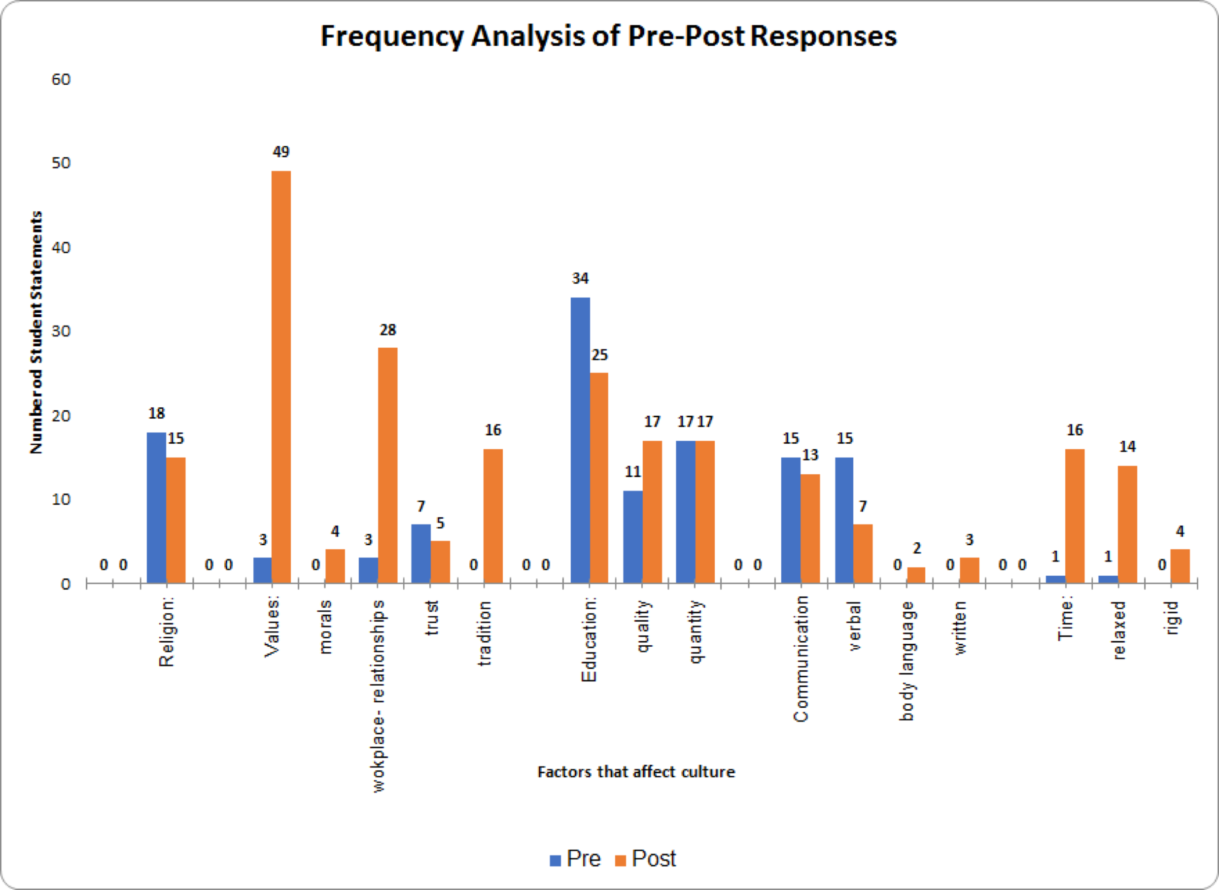

Table 3B: Frequency Analysis of Pre-Post Responses of Factors Affecting Culture
(Stacked Bar Chart)

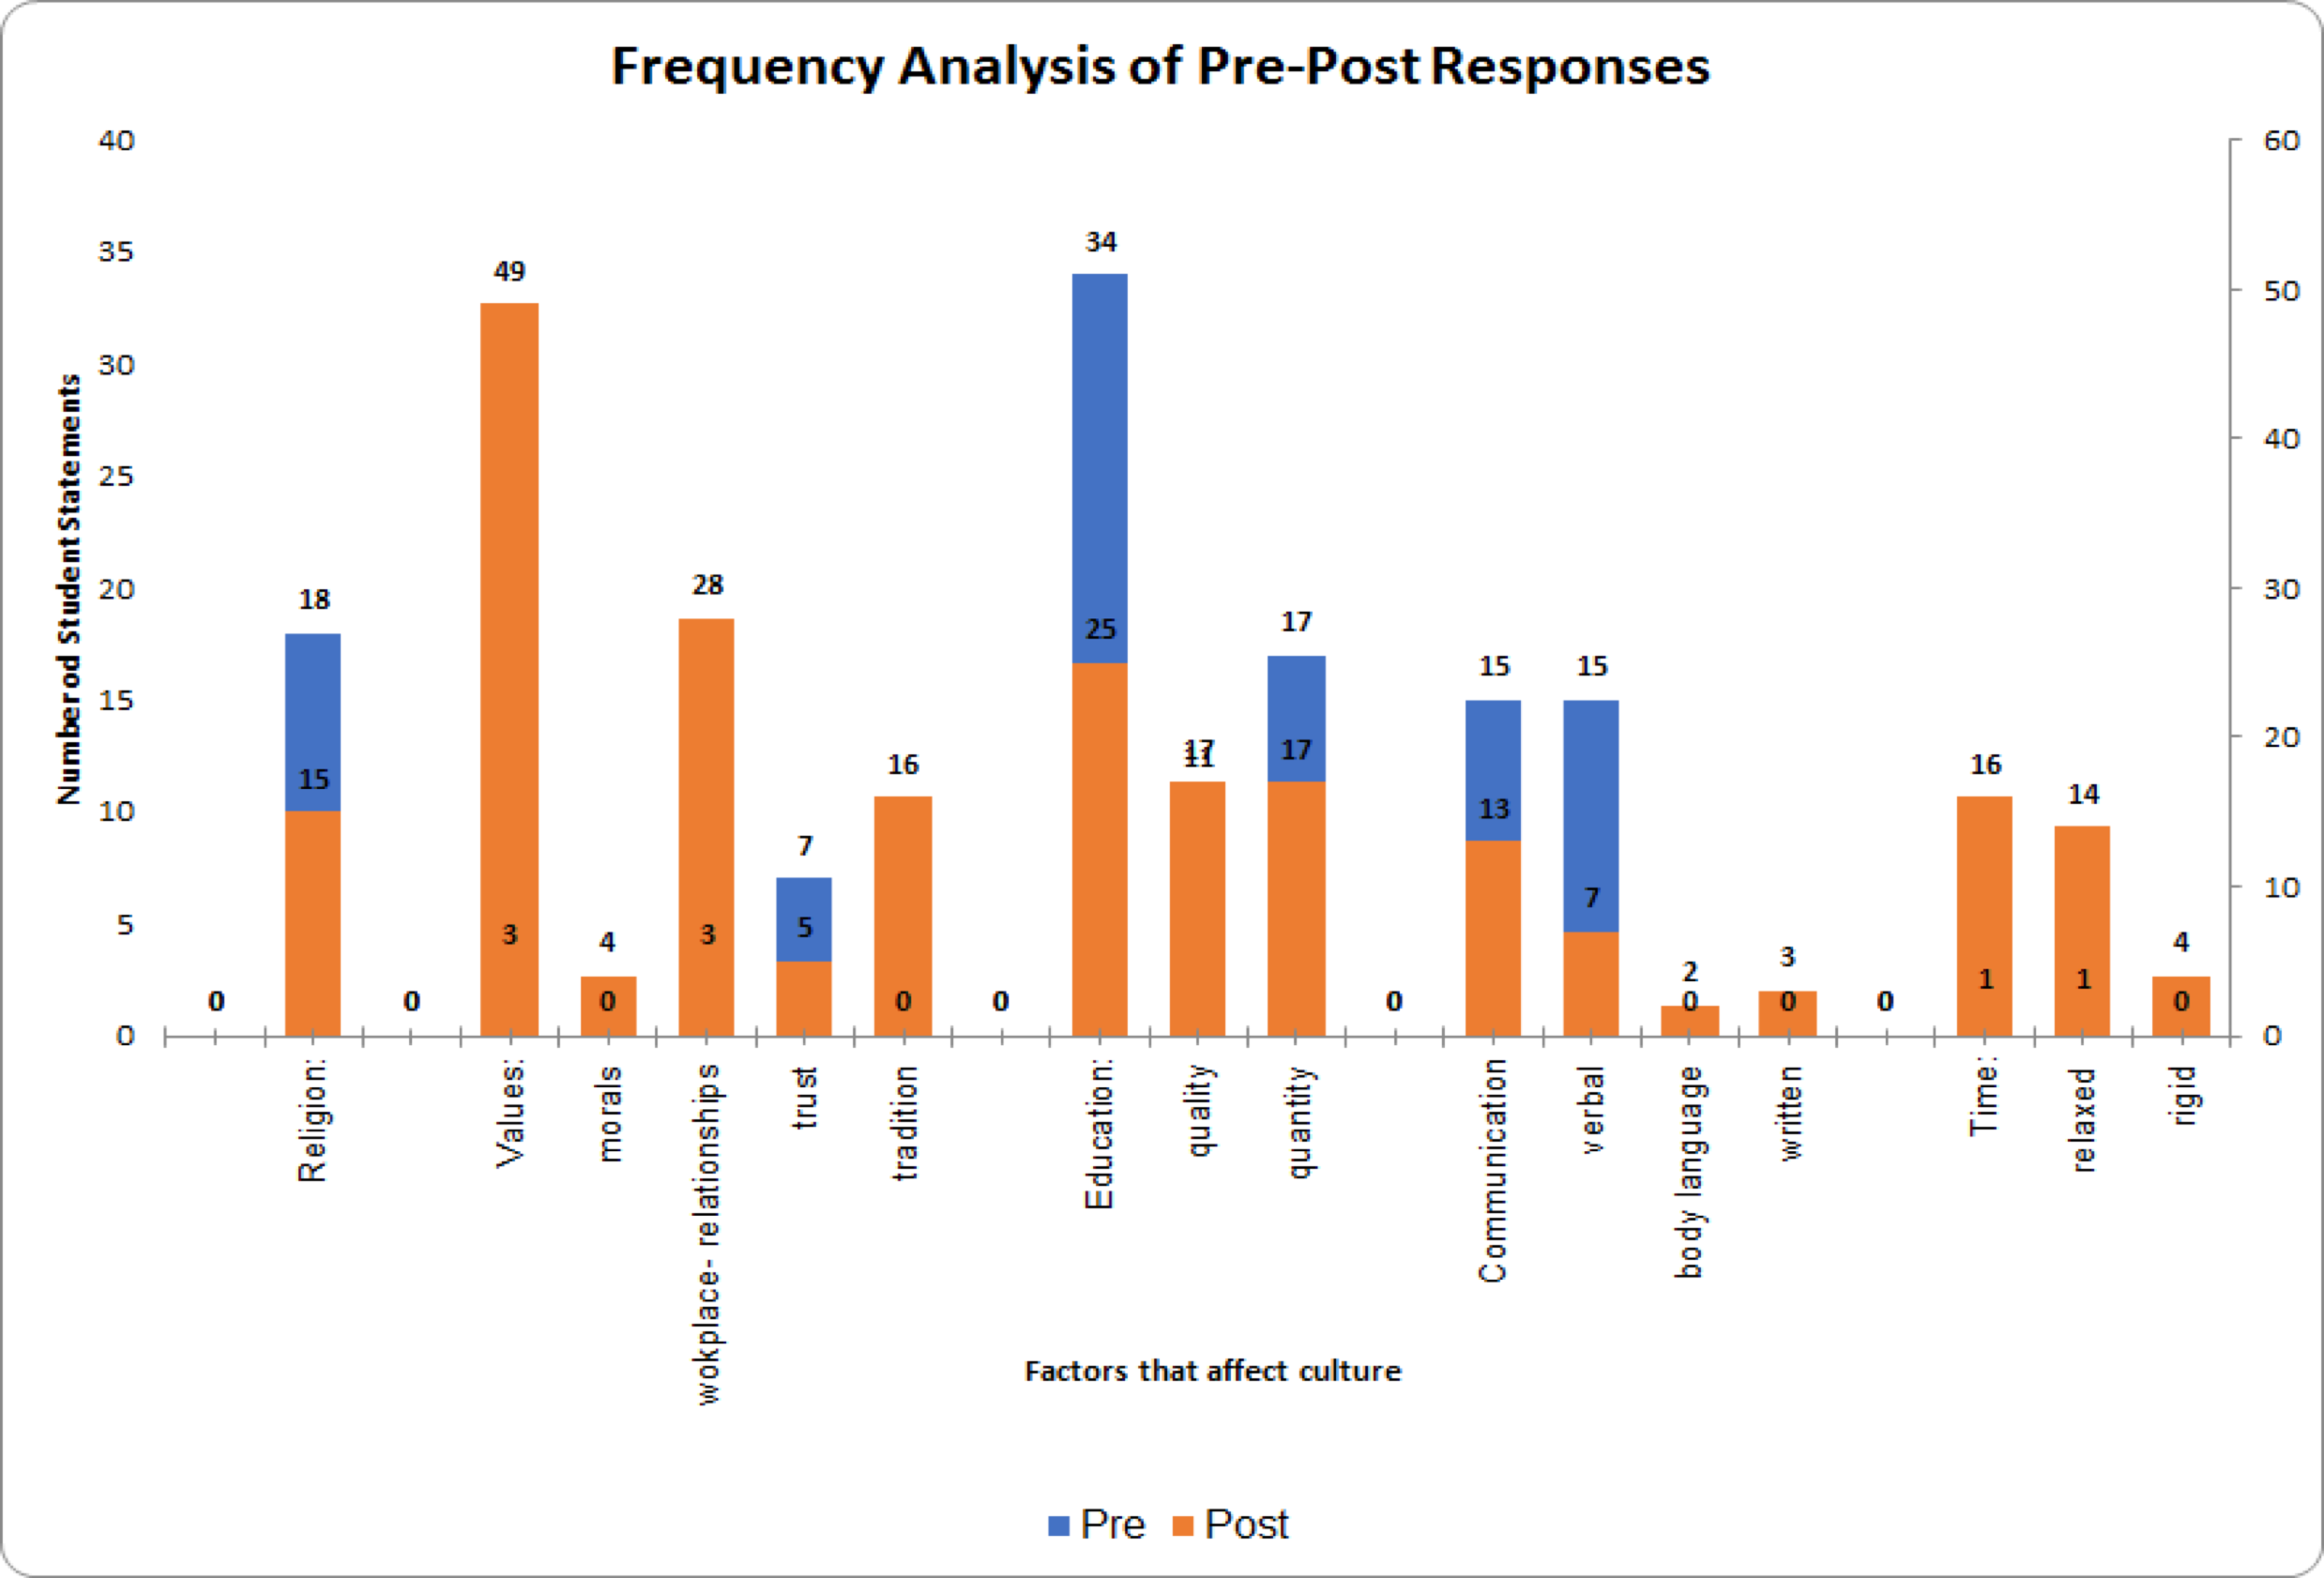

Table 4A: Frequency Analysis of Pre-post Responses of Culture Affecting HRM
(Comparison Bar Chart)

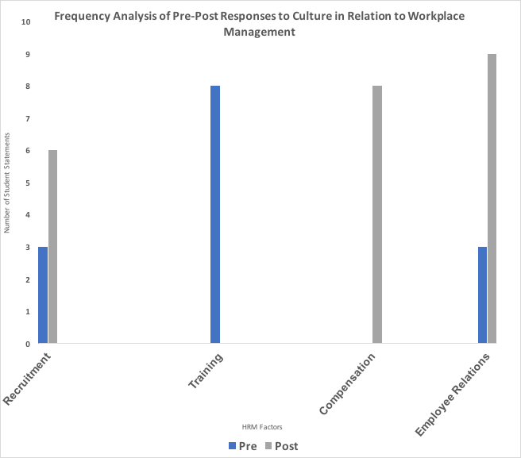

Table 4B: Frequency Analysis of Pre-Post Responses of Culture Affecting HRM
(Stacked Bar Chart)
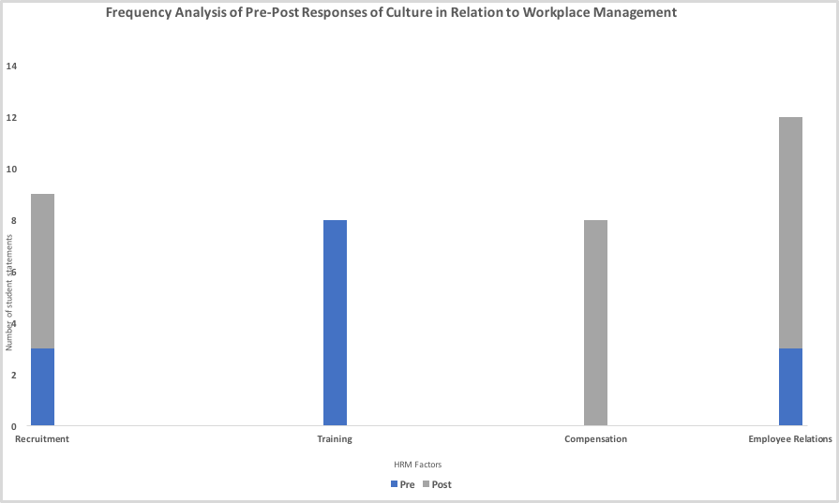
TABLE 5A: SAMPLE STATEMENTS ON HRM FACTORS - PRE

FACTOR | Statement #1 | Statement #2 | Statement #3
Recruitment | “It is vital that this person also have… an open mind to different cultures and ways of life.”- Poland vs Czech Republic | “[The Head of Development] will have to have been with us for years so we can be sure to trust their reliability and ability to manage, run, and operate a team successfully.”- South Korea | “The qualifications for our hotel for the head manager is they… will have to have experience in working a business that crosses cultures.”- Middle East
Training | “Our regional president… will undergo the appropriate training to be familiar with the cultural practices and ready to head Asia operations.”- Asia | “[Our training] will include ethics, company culture, operations, and global mindset training.”- Latin America | “When it comes to expatriates, as HRM we will ensure that there is sufficient training in language and cultural similarities/ differences before the production facility begins operating.”- Volkswagen
Compensation | “Our compensation plan will be universal [to] most employees.”- Latin America | “Our company policies vary by level due to the vastly differing levels of demands and experience required of our different categories of employees.”- Asia | “We would like to aim to implement a norm of reciprocity, where socially we care for our employees and they will respond with contributions of good efforts and appreciation.”- Poland v Czech Republic
Employee Relations | “Promoting equality and collectivism within our company will promote our employees to act accordingly.”- South Korea | “Western management practices of performance management and employee relations must be integrated with those of the Ukraine’s based on its cultural values.”- Eastern Europe | “We accept and are able to accommodate for all religious backgrounds.”- Asia

TABLE 5B: SAMPLE STATEMENTS ON HRM FACTORS - POST

FACTOR | Statement #1 | Statement #2 | Statement #3
Recruitment | “But in Mexico several cultural reason contribute to the recruitment culture which requires such info.”- Latin America | “In terms of recruitment in China, employers focus heavily on written and psychology tests during the selection process.”- China | “Some of the best sources of recruitment are done through connections and networking.”- Africa
Training | “Overall, Middle Eastern companies think that training is key to making a successful company.”- Middle East | “To ensure productivity and development among staff, a training committee needs to be appointed so that a company can be run successfully.”- Africa | “Large Slovenian companies often have their own education and training departments.”- Central & Eastern Europe
Compensation | “But unfortunately in the Philippines, there has been a weak union movement and so compensation as a result has decreased.”- Asia Pacific | “In a region where family helps to define culture, workers would thrive more with benefits that directly relate to this specific need.”- Latin America | “China has its basic pay at a national and industry level in most cases, which could be explained by the national culture and characteristics of the labor market there.”- China
Employee Relations | “As for employee relations, the scene of trade unions have shifted from a monolith to a plural one.”- Central & Eastern Europe | “...culture also plays a large role in the way people are managed from country to country within the Asia Pacific region.”- Asia Pacific | “When conducting employee relations throughout the Middle East, it is extremely important to be sensitive to cultural norms.”- Middle East

